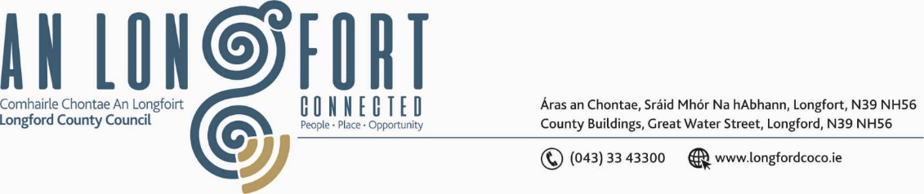

***BALLYMAHON MUNICIPAL DISTRICT***

***Please note meeting will be held in Ballymahon Library.***

**19 January 2023.**

**To: Each Member of Ballymahon Municipal District.**

**Dear Member,**

You are requested to attend a Meeting of Ballymahon Municipal District to be held

**in Ballymahon Library** on **Tuesday 26 January 2023 at 4pm** to transact business, as set out on the agenda hereunder.

**Yours sincerely**,

Claire McNabola

_______________

**Claire McNabola,**

**Meetings Administrator.**

**AGENDA**

Prayer before meeting.

**1.** Confirmation of Minutes of Ballymahon Municipal District Meeting held on the 6 December 2022 – copy enclosed.

**2.** Matters arising from Minutes.

**3.** Declaration of Interest by Members.

**4.** Management Report - enclosed.

**5.** Consideration and adoption of Draft Municipal District Report for inclusion in

Longford County Council 2022 Annual Report – to follow

**6.** Consideration of one Nominee for the Cathaoirleach Awards.

**7. Notices of Motions, submitted by Councillors, as listed hereunder –**

**Councillor Mark Casey**

1. I seek a full breakdown on the works completed on the Lanesborough Amphitheatre project and timelines for its completion date.

1. “I call on Longford County Council to resurface the road from the 4 roads at L1168 (Lisreevah road) to the Rathcline Road”.
2. “I call on Longford County Council to prioritise the resurfacing of the Rathcline road in 2023”.

**Councillor Paul Ross**

1. I call on Longford County Council to install wheelchair accessible parking on the Main Street in Edgeworthstown as none currently exists.

1. I call on Longford County Council to put up signage indicating the location of the free car park in Edgeworthstown.

**Councillor Gerard Farrell**

1. I call on Longford County Council take action to fix the drainage issue at O’Brien’s Corner Shop, Lanesboro.
2. I call on Longford County Council to provide an update on progress with retro fitting in the Ballymahon area.
3. I call on Longford County Council to provide an update on the progress of projects in the Lanesboro area.

**Councillor Pat O’Toole**

1. I call on Longford County Council to consider including the Parkside Gardens Estate Ballymahon (20 houses) in the next round of the Council's retrofitting programme 2023/24.
2. I call on Longford County Council to give an update to this municipal meeting on the works required to complete the cycleway / walkway from Ballymahon bridge to Newcastle bridge and what is the timeline for the completion of this most desirable project